Apex in Solid Geometry

Definition
# Source: AI Source: Provided by: [Data Path: Persons Table -> ID Column: 1, Name_En Column: Motasem Essam] -> From: [ChatGPT] on [7/25/2026]
An apex is the vertex at which the lateral edges or lateral surfaces of a pyramid or cone meet. It is the pointed end of the solid, opposite its base.
In a pyramid, the apex is the common vertex of all triangular lateral faces. In a cone, the apex is the point where the curved lateral surface narrows to a tip.
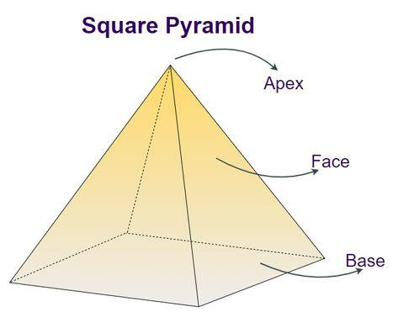
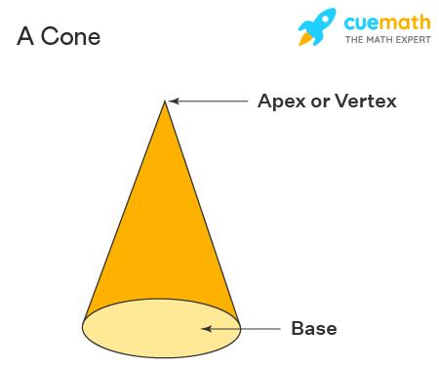
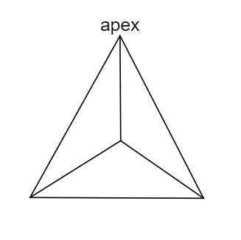

Simple Definition
# Source: AI Source: Provided by: [Data Path: Persons Table -> ID Column: 1, Name_En Column: Motasem Essam] -> From: [ChatGPT] on [7/25/2026]
The apex is the top point or tip of a pyramid or cone.
Examples:
- The pointed vertex of a square pyramid.
- The pointed tip of a cone.
- The common vertex where the triangular faces of a triangular pyramid meet.
The apex does not have to be physically above the base. If the solid is rotated, the apex may point sideways or downward.

Classification Tree
# Source: AI Source: Provided by: [Data Path: Persons Table -> ID Column: 1, Name_En Column: Motasem Essam] -> From: [ChatGPT] on [7/25/2026]
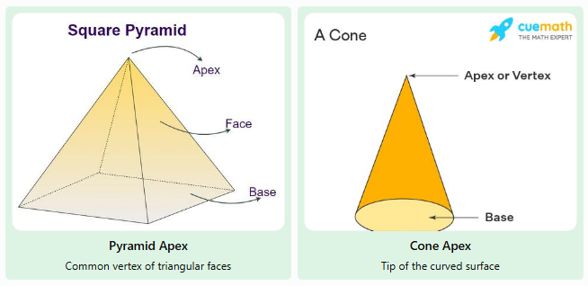
Pyramid Apex
Common vertex of triangular faces
Cone Apex
Tip of the curved surface

Key Characteristics of an Apex
# Source: AI Source: Provided by: [Data Path: Persons Table -> ID Column: 1, Name_En Column: Motasem Essam] -> From: [ChatGPT] on [7/25/2026]
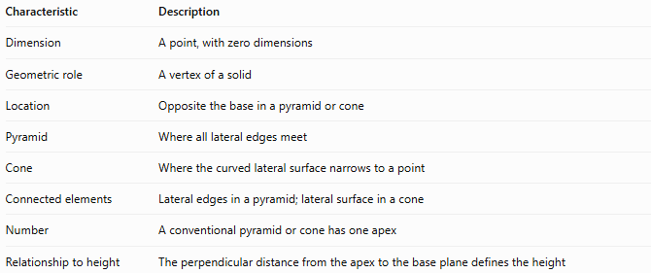
Characteristic | Description
Dimension | A point, with zero dimensions
Geometric role | A vertex of a solid
Location | Opposite the base in a pyramid or cone
Pyramid | Where all lateral edges meet
Cone | Where the curved lateral surface narrows to a point
Connected elements | Lateral edges in a pyramid; lateral surface in a cone
Number | A conventional pyramid or cone has one apex
Relationship to height | The perpendicular distance from the apex to the base plane defines the height

Geometric Representation

A. Apex of a pyramid
# Source: AI Source: Provided by: [Data Path: Persons Table -> ID Column: 1, Name_En Column: Motasem Essam] -> From: [ChatGPT] on [7/25/2026]
In a pyramid, the apex is the vertex opposite the base. Each vertex of the base is connected to the apex by a lateral edge.
For a square pyramid:
- There is one apex.
- There are four lateral edges.
- There are four triangular lateral faces.
- There is one square base.
For a pyramid with an $n$-sided base, there is one apex, $n$ lateral edges, and $n$ triangular lateral faces.
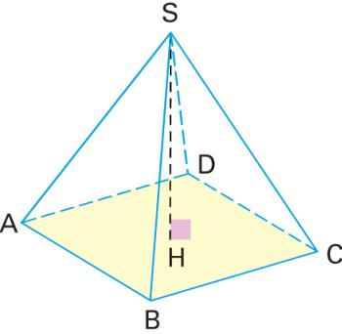

B. Apex of a cone
# Source: AI Source: Provided by: [Data Path: Persons Table -> ID Column: 1, Name_En Column: Motasem Essam] -> From: [ChatGPT] on [7/25/2026]
In a cone, the apex is the point where the curved lateral surface ends. Every straight line segment from the apex to the circular boundary of the base is a slant segment; in a right circular cone, all such segments have the same length.
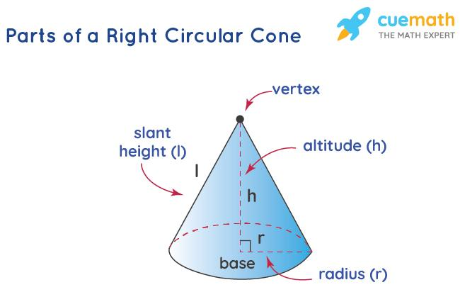

C. Apex versus base
# Source: AI Source: Provided by: [Data Path: Persons Table -> ID Column: 1, Name_En Column: Motasem Essam] -> From: [ChatGPT] on [7/25/2026]
The base is a two-dimensional region, while the apex is a single point.
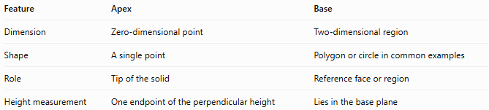
Feature | Apex | Base
Dimension | Zero-dimensional point | Two-dimensional region
Shape | A single point | Polygon or circle in common examples
Role | Tip of the solid | Reference face or region
Height measurement | One endpoint of the perpendicular height | Lies in the base plane

Mathematical Representation

A. Apex coordinates
# Source: AI Source: Provided by: [Data Path: Persons Table -> ID Column: 1, Name_En Column: Motasem Essam] -> From: [ChatGPT] on [7/25/2026]
For a right pyramid or right circular cone with a horizontal base in the plane $z=0$, the apex may be represented as
$$A=\left(0,0,h\right)$$
where $h$ is the perpendicular height above the base plane, assuming the origin is at the center of the base.
The base plane is
$$z=0$$
and the perpendicular height is the distance from the apex to that plane.

B. Height of a right circular cone
# Source: AI Source: Provided by: [Data Path: Persons Table -> ID Column: 1, Name_En Column: Motasem Essam] -> From: [ChatGPT] on [7/25/2026]
For a right circular cone, the radius $r$, perpendicular height $h$, and slant height $l$ satisfy the Pythagorean relationship
$$l^{2}=r^{2}+h^{2}$$
Therefore,
$$h=\sqrt{l^{2}-r^{2}}$$
This formula applies to a right circular cone, where the apex is directly above the center of the circular base.

C. Height of a regular right pyramid
# Source: AI Source: Provided by: [Data Path: Persons Table -> ID Column: 1, Name_En Column: Motasem Essam] -> From: [ChatGPT] on [7/25/2026]
For a regular right pyramid, let:
- $h$ be the perpendicular height.
- $R$ be the distance from the center of the base to a base vertex.
- $l_{e}$ be the lateral edge length from the apex to a base vertex.
Then
$$l_{e}=\sqrt{h^{2}+R^{2}}$$
This follows from the right triangle formed by the apex, the center of the base, and a base vertex.

Worked Examples
# Source: AI Source: Provided by: [Data Path: Persons Table -> ID Column: 1, Name_En Column: Motasem Essam] -> From: [ChatGPT] on [7/25/2026]
Example 1: Counting the lateral edges of a square pyramid
A square pyramid has four vertices around its base and one apex.
Each base vertex connects to the apex through one lateral edge.
$$E_{L}=4$$
Answer: The square pyramid has four lateral edges and one apex.
Example 2: Finding the height of a cone
A right circular cone has a slant height of $13\text{ cm}$ and a base radius of $5\text{ cm}$. Find its perpendicular height.
Using the formula:
$$h=\sqrt{l^{2}-r^{2}}$$
Substitute the values:
$$h=\sqrt{{13}^{2}-5^{2}}$$
$$h=\sqrt{169-25}=\sqrt{144}=12$$
Answer: The cone's perpendicular height is $12\text{ cm}$.
Example 3: Finding the lateral edge of a pyramid
A regular right pyramid has a perpendicular height of $12\text{ cm}$, and the distance from the center of its base to a base vertex is $5\text{ cm}$. Find the lateral edge length.
$$l_{e}=\sqrt{h^{2}+R^{2}}$$
$$l_{e}=\sqrt{{12}^{2}+5^{2}}=\sqrt{169}=13$$
Answer: Each lateral edge is $13\text{ cm}$.
This result assumes the pyramid is a regular right pyramid, so the apex is directly above the center of its base.

Comparison with Related Geometric Terms
# Source: AI Source: Provided by: [Data Path: Persons Table -> ID Column: 1, Name_En Column: Motasem Essam] -> From: [ChatGPT] on [7/25/2026]
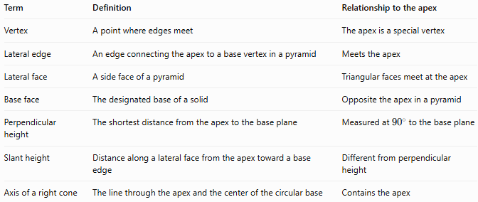
Term | Definition | Relationship to the apex
Vertex | A point where edges meet | The apex is a special vertex
Lateral edge | An edge connecting the apex to a base vertex in a pyramid | Meets the apex
Lateral face | A side face of a pyramid | Triangular faces meet at the apex
Base face | The designated base of a solid | Opposite the apex in a pyramid
Perpendicular height | The shortest distance from the apex to the base plane | Measured at \(90^\circ\) to the base plane
Slant height | Distance along a lateral face from the apex toward a base edge | Different from perpendicular height
Axis of a right cone | The line through the apex and the center of the circular base | Contains the apex
Important distinction: The apex is a vertex, but not every vertex is an apex. For example, the eight corners of a cube are vertices, but a cube has no apex in the usual geometric terminology.

Applications of the Apex
# Source: AI Source: Provided by: [Data Path: Persons Table -> ID Column: 1, Name_En Column: Motasem Essam] -> From: [ChatGPT] on [7/25/2026]
- Architecture: Identifying the pointed top of pyramidal roofs and structures.
- Engineering: Determining dimensions and angles of conical and pyramidal components.
- Geometry: Calculating heights, slant heights, lateral edges, and volumes.
- Computer graphics: Defining the tip and triangular mesh structure of pyramids and cones.
- Manufacturing: Designing pointed tools, conical parts, and tapered objects.

Key Points
# Source: AI Source: Provided by: [Data Path: Persons Table -> ID Column: 1, Name_En Column: Motasem Essam] -> From: [ChatGPT] on [7/25/2026]
- An apex is the pointed vertex of a pyramid or cone.
- A conventional pyramid or cone has one apex.
- A pyramid's lateral edges and triangular lateral faces meet at its apex.
- A cone's curved lateral surface narrows to its apex.
- The perpendicular height is measured from the apex to the base plane.
- The slant height and lateral edge length are not generally the same as the perpendicular height.
- Rotating a solid changes the apparent position of its apex, not its geometric identity.

Conclusion
# Source: AI Source: Provided by: [Data Path: Persons Table -> ID Column: 1, Name_En Column: Motasem Essam] -> From: [ChatGPT] on [7/25/2026]
The apex in solid geometry is the special vertex at which the lateral edges or lateral surface of a pyramid or cone converge. It is essential for describing the structure of these solids and calculating their heights, slant dimensions, and volumes.

